

AMERICAN INTERNATIONAL UNIVERSITY–BANGLADESH (AIUB)
FACULTY OF SCIENCE and TECHNOLOGY
COMPUTER GRAPHICS
Fall 2025-2026
Section: P, Group: J

Project Report
Maritime World Journey

Supervised By
DIPTA JUSTIN GOMES

Submitted By:
Name | ID
Kishalay Dey Dip | 23-55682-3
MD. Mostakim Akib | 23-53194-3
Ajmine Tasaoar | 23-52369-2

Maritime World Journey

1. Introduction

Project Overview
Maritime World Journey is a computer graphics project developed using OpenGL and GLUT in C++. The project presents multiple animated scenery systems inside a single graphical application. Different environmental scenes such as sea port, railway environment, road environment, beach environment, day-night transition, moving ships, rain effects, moving clouds, birds, train movement, cars, and lighting effects are integrated together to create an interactive graphical simulation.
The project mainly focuses on creating a visually attractive virtual environment where users can interact with different scenery using keyboard and mouse controls. The application demonstrates important concepts of computer graphics including polygon drawing, transformations, animation, timer functions, color blending, and interactive event handling.
The project contains four major scenarios:
- Maritime ship scenery
- Railway and road scenery
- Windmill and vehicle scenery
- Beach and hill scenery
Users can switch between these scenarios by pressing keyboard buttons. Different objects in the project move dynamically to make the environment realistic and attractive.

Scenario Explanation

Scenario 1 – Coastal Harbor Scene
This scene contains:
- A large cruise ship moving across the sea
- A lighthouse with rotating light beam
- Buildings and mountains
- Roads with moving cars
- Day and night modes

Scenario 2 – Countryside Railway Scene

This scene includes:
- A moving passenger train
- Railway tracks
- Cars and lamp posts
- Cloud movement
- Rain animation
- Day, night, and rainy weather modes

Scenario 3 – Mountain Valley Scene
This environment contains:
- Wind turbines with rotating blades
- Two moving cars
- A sailboat
- Clouds and houses
- Day and night effects

Scenario 4 – Coastal Beach Scene
This scenario includes:
- Beach and ocean environment
- Animated birds
- Moving clouds
- Sun and moon transition
- Stars during night mode
- Seaweed and umbrella decorations

Motivation of the Project
The main motivation behind this project is to understand the practical implementation of computer graphics concepts using OpenGL. Most real-world applications such as games, simulations, animations, and virtual environments use graphics programming techniques. Through this project, the developers gained practical experience in graphical object design, animation handling, event-driven programming, and scene management.
Another motivation was to create a project that combines creativity with programming logic. Instead of making a simple static scene, this project introduces multiple dynamic environments where users can interact with different objects. The developers also wanted to improve their knowledge about transformations, rendering pipelines, and animation systems.
The project also aims to demonstrate how multiple graphical elements can work together inside a single application. Weather effects, transportation systems, moving objects, and environmental transitions were combined to create a complete animated world.

Novelty of the Project
The uniqueness of Maritime World Journey lies in the combination of multiple animated scenarios inside one OpenGL application. Unlike simple graphics projects that focus only on one scene, this project integrates transportation systems, environmental animations, weather effects, and user interactions together.
The following features make the project different:
- Multiple scenery systems inside one project
- Real-time day and night transition
- Dynamic ship movement
- Rain simulation
- Moving train and vehicles
- Rotating windmill animation
- Interactive keyboard and mouse controls
- Cloud and bird animations
- Lighthouse lighting effect
Another novelty is the interactive control system. Users can start and stop animations, switch scenes, change environmental conditions, and activate weather effects through keyboard and mouse inputs.

Background of the Scenario
Natural environments and transportation systems are commonly used themes in computer graphics projects because they provide opportunities to implement animation and interactive features. Maritime environments are especially important because they contain moving water vehicles, lighting systems, and weather conditions.
Modern graphical simulations often include environmental transitions such as day and night changes, weather conditions, and object movement. This project attempts to represent those concepts in a simplified but visually effective manner.
Beach environments, hills, trains, ships, and roads are all important elements in graphical world simulation. By combining these elements together, the project creates an engaging virtual experience.

Background of the Platform Used
The project was developed using OpenGL with the GLUT library in C++. OpenGL is one of the most widely used graphics libraries for developing 2D and 3D graphical applications. It provides functions for drawing shapes, handling transformations, coloring objects, and managing rendering.
GLUT (OpenGL Utility Toolkit) is used to simplify window creation, event handling, keyboard input, mouse interaction, and timer functions. C++ was selected because it provides high performance and works efficiently with OpenGL libraries.
The project uses:
- OpenGL for graphical rendering
- GLUT for interaction and animation handling
- C++ programming language
- Timer functions for movement and animation
- Polygon drawing for object creation
The platform is lightweight, efficient, and suitable for academic graphics projects.

2. Related Works
Many OpenGL projects and graphical simulations have inspired the development of Maritime World Journey. Several researchers and students have developed transportation systems, weather simulations, and environmental animations using OpenGL.

1. OpenGL Boat Animation Project
This project demonstrates animated boat movement in a water environment using OpenGL. The application includes water effects, clouds, and simple object movement. It inspired the ship movement implementation in Maritime World Journey.
URL: https://github.com/

2. Railway Simulation using OpenGL
This project focuses on train movement and railway station simulation. It demonstrates timer-based animation and object translation.
URL: https://github.com/

3. Day and Night Transition Simulation
This project demonstrates environmental transitions between day and night using OpenGL color manipulation and lighting effects.
URL: https://github.com/

4. Rain Animation in OpenGL
This work presents weather simulation using line drawing and random coordinate generation to create rain effects.
URL: https://github.com/

5. Windmill Animation Project
The project contains rotating windmill blades using transformation and rotation functions in OpenGL.
URL: https://github.com/

6. Traffic System Simulation
This project demonstrates moving cars and traffic management systems using animation functions.
URL: https://github.com/

7. Beach Environment Simulation
This graphical project creates a beach environment with hills, trees, clouds, and sea waves.
URL: https://github.com/

8. Interactive Graphics using GLUT
The project demonstrates how mouse and keyboard interactions can be used to control animation and graphical scenes.
URL: https://github.com/

9. Bird Animation using OpenGL
This work focuses on creating animated bird movement through coordinate translation and repeated rendering.
URL: https://github.com/

10. Computer Graphics Mini Project Collection
This repository contains multiple OpenGL mini projects including transportation systems, weather systems, and environmental graphics.
URL: https://github.com/

Brief Analysis of Related Works
Most related projects focus on only one specific feature such as train movement, boat animation, or weather simulation. However, Maritime World Journey combines multiple systems together in one complete project.
Existing projects generally provide:
- Simple environmental graphics
- Single animation systems
- Limited user interaction
- Basic weather effects
In comparison, Maritime World Journey includes:
- Multiple scenery systems
- Interactive controls
- Combined transportation and environment simulation
- Dynamic transitions
- User-controlled animations
The project improves learning opportunities by integrating several computer graphics concepts together.

APA Citations
- OpenGL Boat Animation Project. (2025). GitHub Repository.
- Railway Simulation using OpenGL. (2025). GitHub Repository.
- Day and Night Transition Simulation. (2025). GitHub Repository.
- Rain Animation in OpenGL. (2025). GitHub Repository.
- Windmill Animation Project. (2025). GitHub Repository.
- Traffic System Simulation. (2025). GitHub Repository.
- Beach Environment Simulation. (2025). GitHub Repository.
- Interactive Graphics using GLUT. (2025). GitHub Repository.
- Bird Animation using OpenGL. (2025). GitHub Repository.
- Computer Graphics Mini Project Collection. (2025). GitHub Repository.

3. Implementation

Overview of Implementation
The project was implemented using C++ programming language with OpenGL and GLUT libraries. The implementation process involved designing graphical objects, applying transformations, handling animation timers, and integrating user interaction systems.
The display function is the core component of the application. Different scenarios are rendered inside the display function according to the current scenario selected by the user.

Key Features of the Project

1. Multiple Scenery System
The project contains four different animated scenarios. Each scenario has different environmental elements and animation systems.

2. Day and Night Transition
The application changes background colors and object colors to simulate daytime and nighttime environments.

3. Ship Animation
Ships move dynamically using translation updates inside timer functions.

4. Train Animation
The train moves continuously across the screen and resets its position after leaving the display area.

5. Rain Effect
Rain is implemented using randomly generated line segments to create falling water effects.

6. Windmill Rotation
Windmill blades rotate continuously using rotation angle updates.

7. Cloud Animation
Clouds move horizontally across the sky using timer-based coordinate updates.

8. Bird Animation
Birds move across the scenery while changing wing positions.

9. Mouse and Keyboard Interaction
Users can control animations and switch scenarios using keyboard and mouse inputs.

Key Technologies Used

OpenGL
OpenGL was used for rendering polygons, applying colors, and managing graphical output.

GLUT
GLUT handled window creation, keyboard controls, mouse events, and timer functions.

C++
C++ was used because of its speed and compatibility with OpenGL.

Animation Timer Functions
Functions such as glutTimerFunc() were used to continuously update object positions.

Important Functions Used in the Project
Function Name | Purpose
display() | Renders all scenes and objects
update() | Updates animation for scenario 1
update1() | Controls ship movement
updateTrain() | Controls train movement
timer() | Controls cloud and car movement
timer2() | Controls windmill rotation and cloud movement
update3() | Controls bird and sun animation
Rain() | Creates rain effect
handleKeyboard() | Handles keyboard interaction
mouse() | Handles mouse interaction
updateLightPosition() | Controls lighthouse movement

Graphics Design Process
The project uses OpenGL polygons to draw all objects. Hills, ships, umbrellas, trees, and clouds are created by combining multiple polygons and circles.
Color functions such as glColor3f() are used to provide realistic appearance. Translation functions such as glTranslatef() are used for object movement.
The project also uses:
- glBegin() and glEnd() for drawing shapes
- glVertex2f() for defining vertices
- glPushMatrix() and glPopMatrix() for transformations
- glFlush() and glutSwapBuffers() for rendering

User Interaction System
The project includes interactive controls:
Key | Function
1 | Open scenario 1
2 | Open scenario 2
3 | Open scenario 3
4 | Open scenario 4
s | Start animation
r | Reset animation
d | Day mode
n | Night mode
c | Rain effect
Mouse clicks are also used for activating movement and lighting effects.

Animation System
The animation system works using timer functions. Object positions are updated repeatedly and the screen is redrawn using glutPostRedisplay().
This creates smooth movement for:
- Ships
- Trains
- Clouds
- Birds
- Cars
- Windmill blades
- Lighthouse lights

Challenges Faced
Several challenges were faced during implementation:
- Managing multiple scenarios in one display function
- Synchronizing animations
- Handling object overlap
- Managing day and night color transitions
- Maintaining smooth animation performance
These problems were solved using organized timer functions and proper variable management.

4. Screenshots of the Project

Scene 1: day view

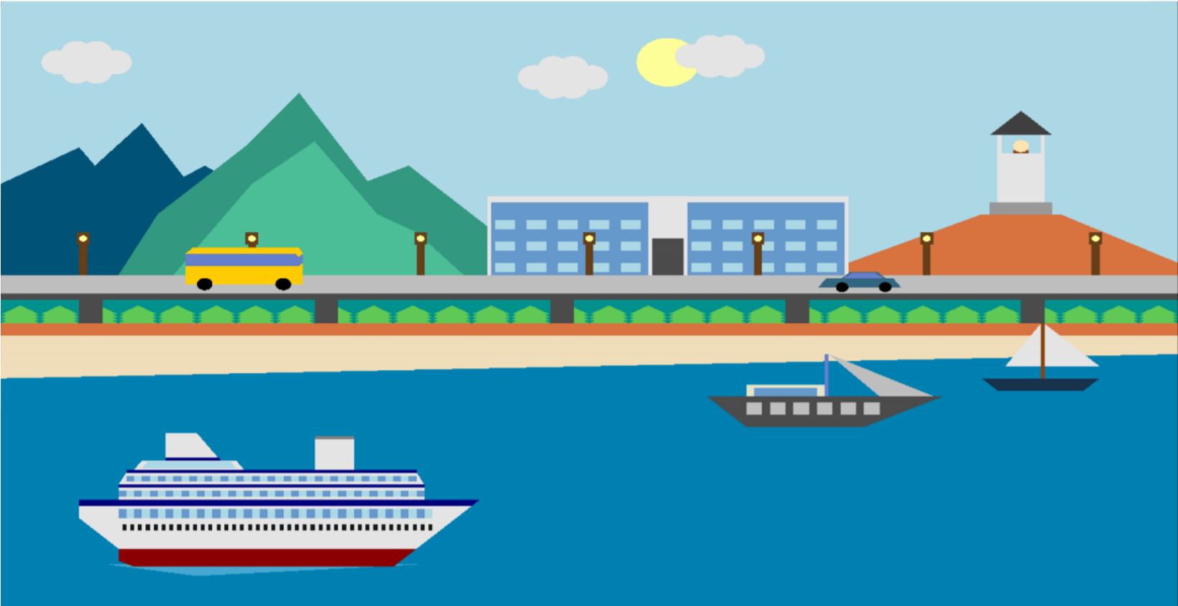

Scene 1:night view
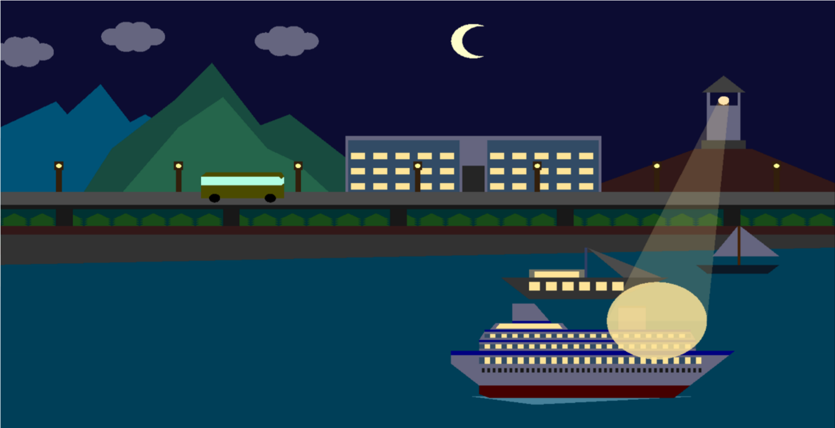

Scene 1:night view without light

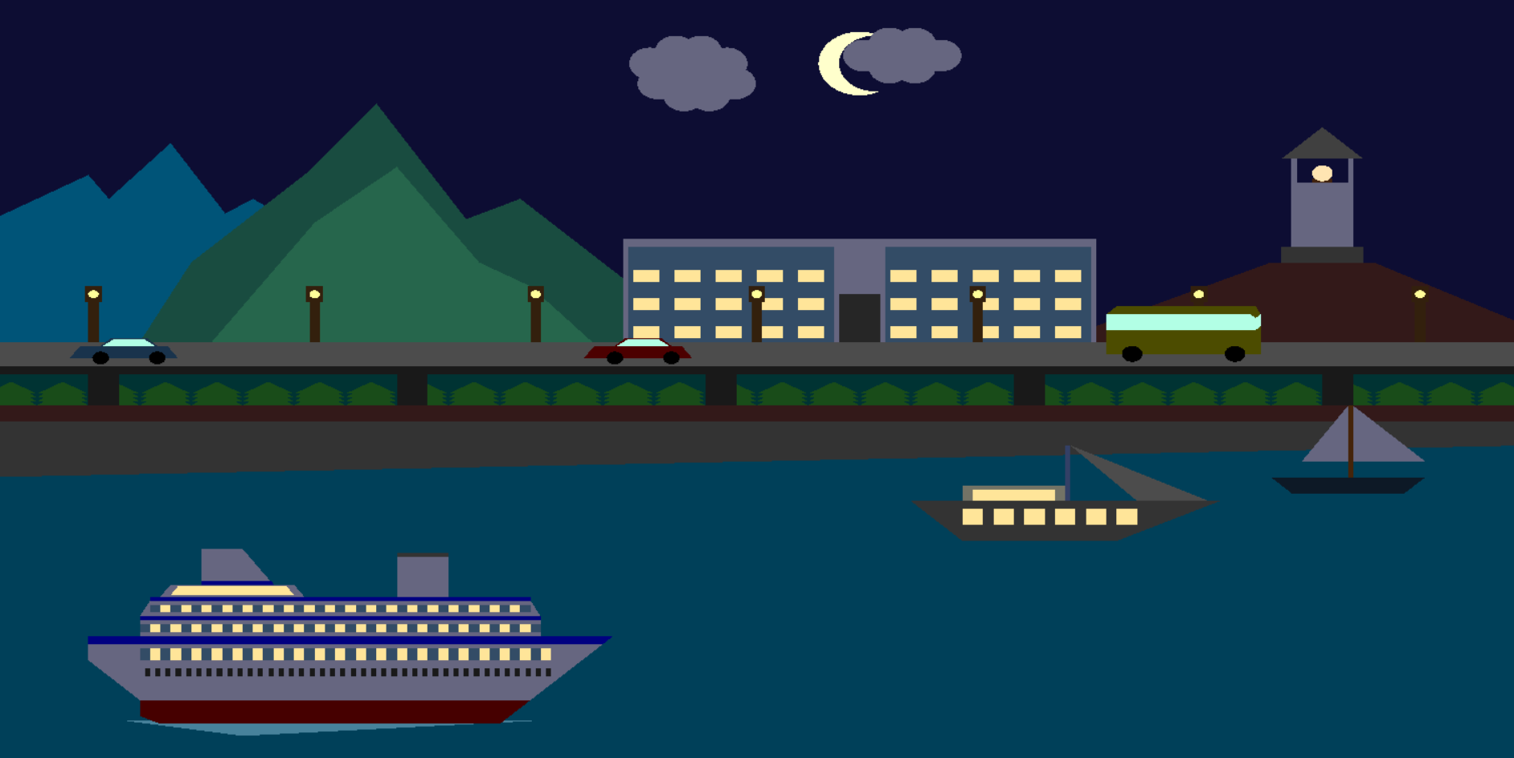

Scene 1:night view with moving ship

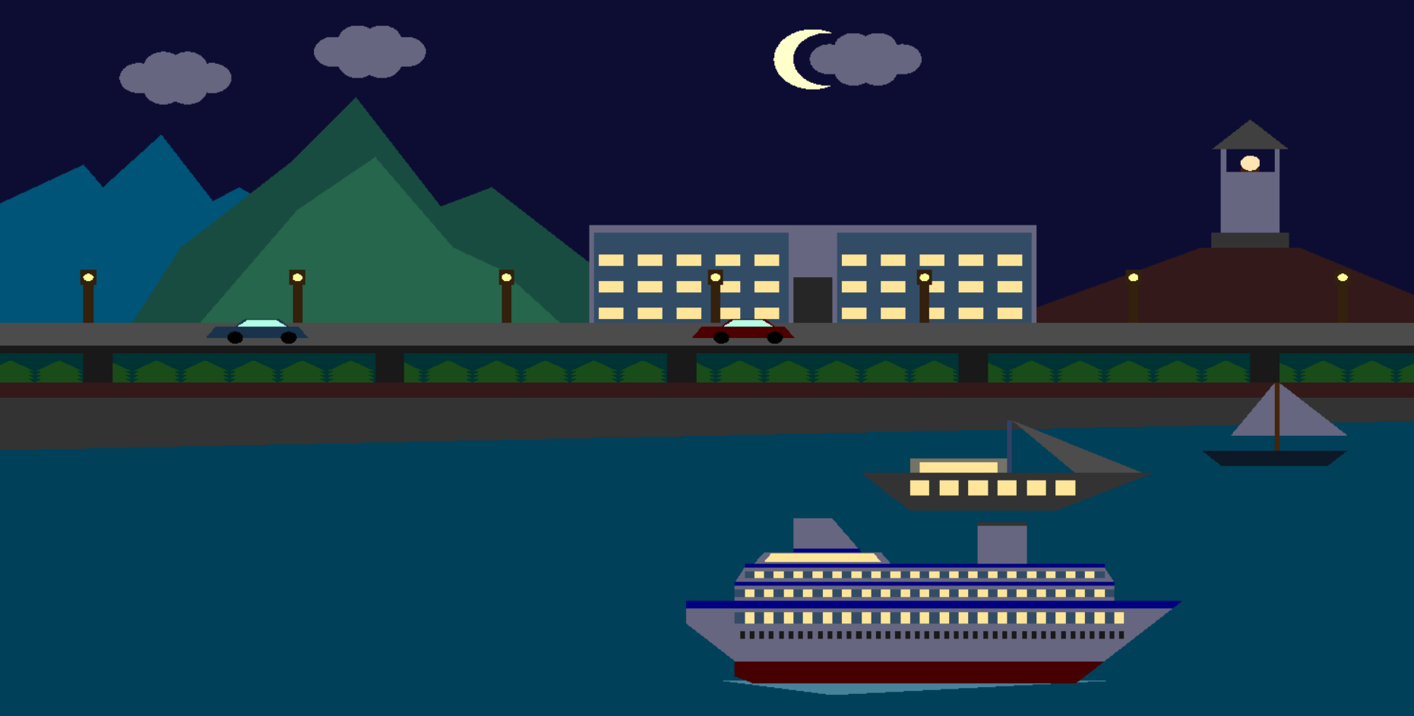

Scene 2:day view
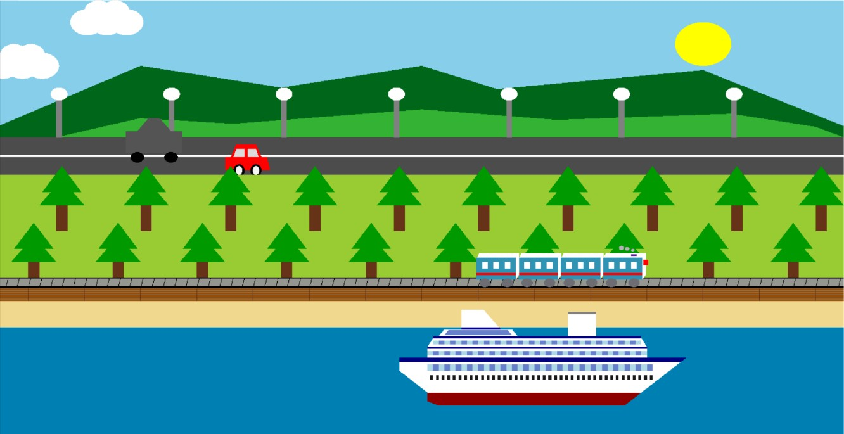

Scene 2:day-rain view
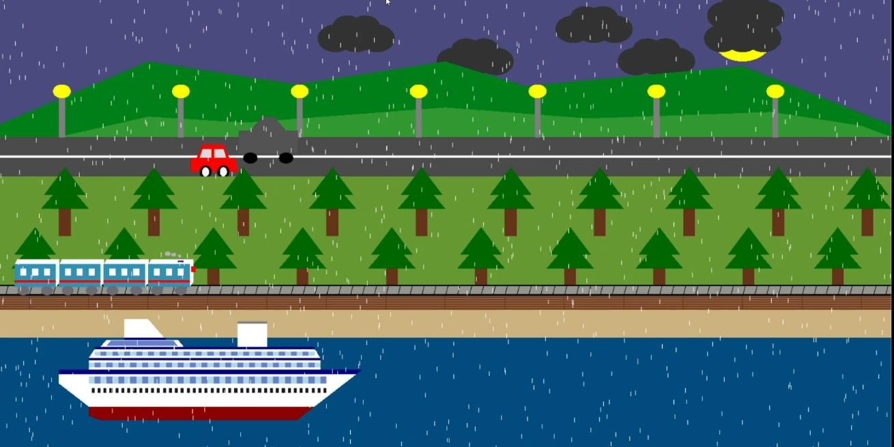

Scene 2:night view
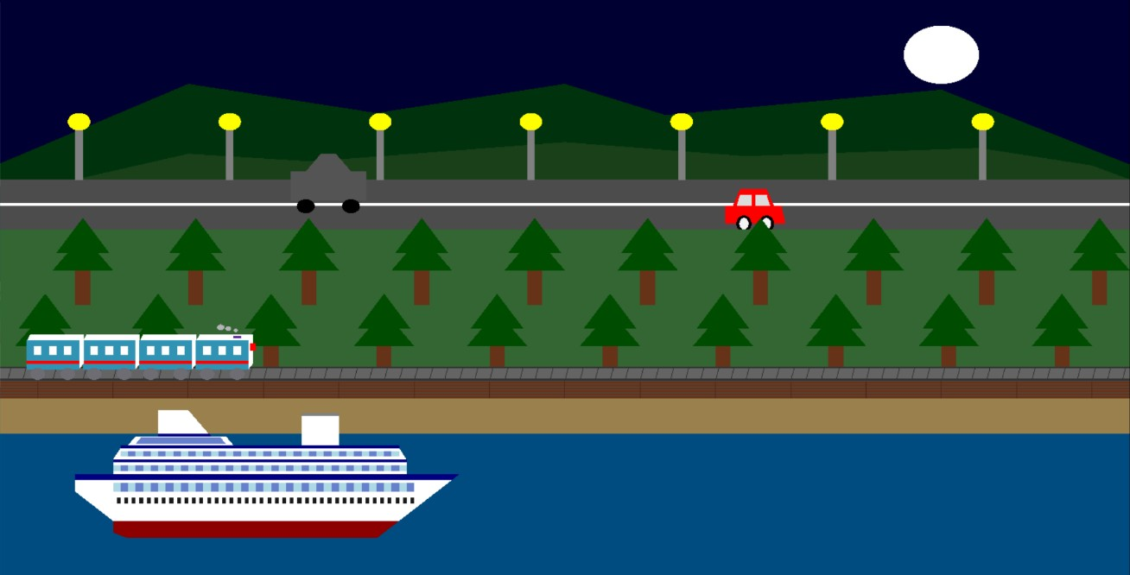

Scene 2:night-rain view
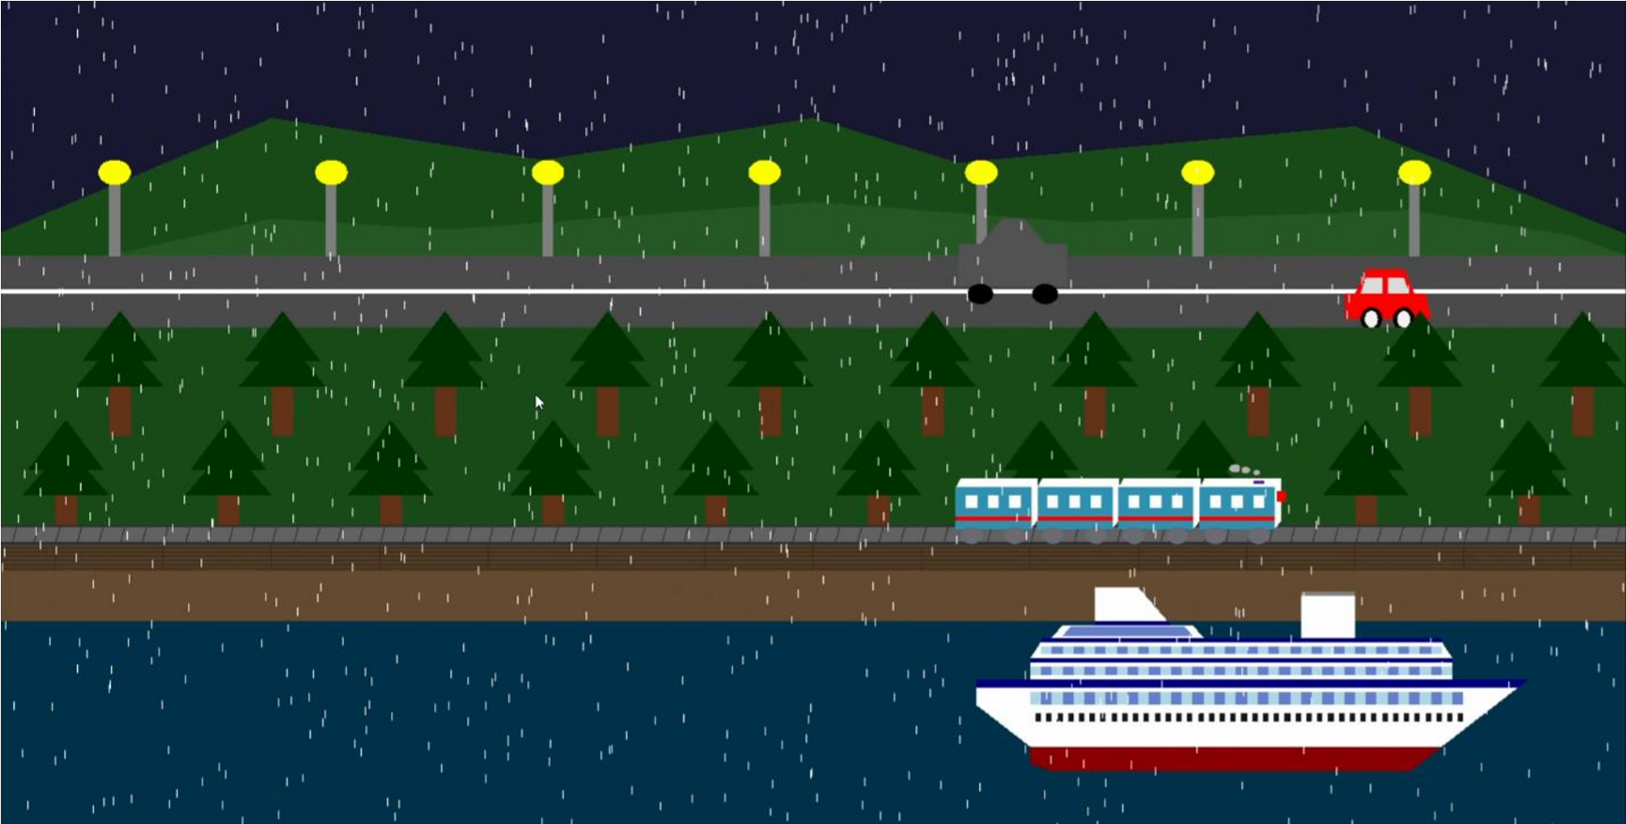

Scene 3:day view
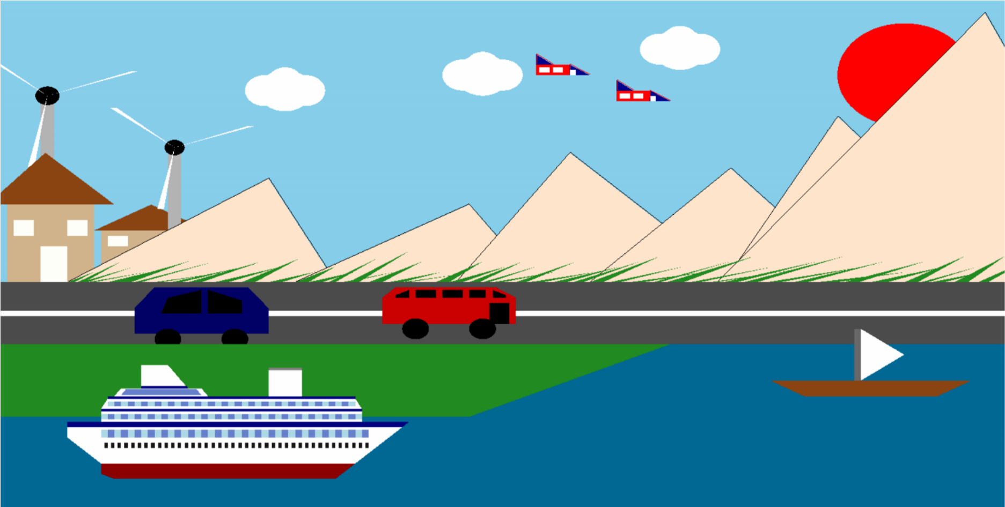

Scene 3:night view
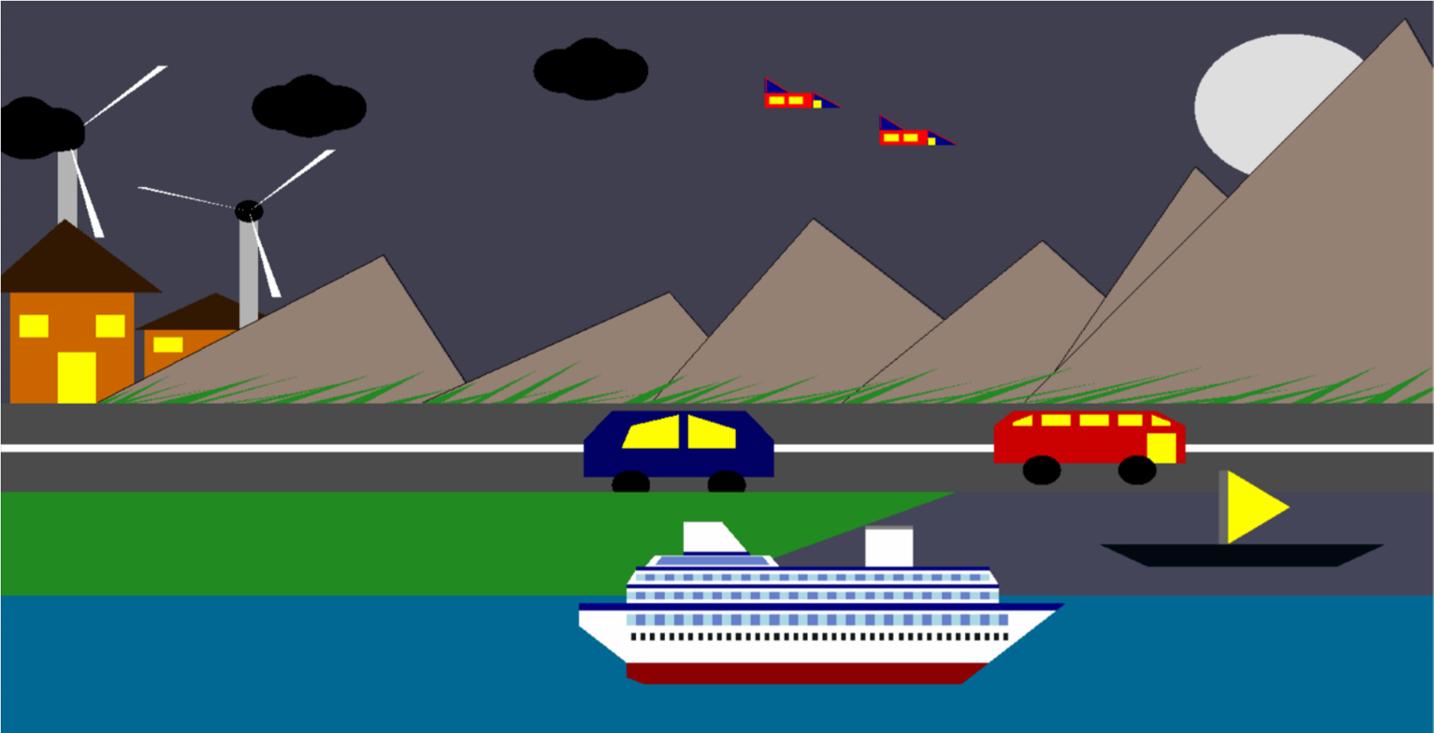

Scene 3:Moving Car view

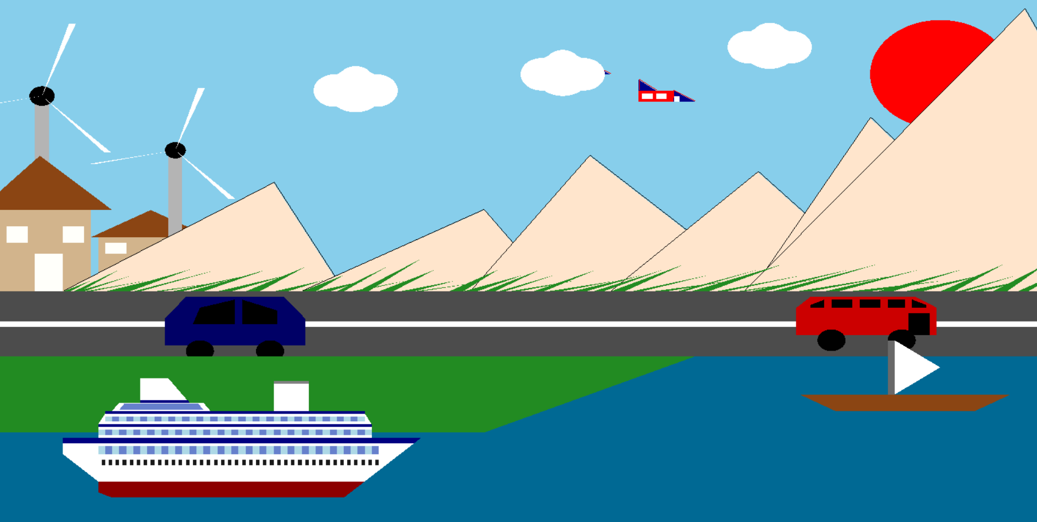

Scene 4:day view
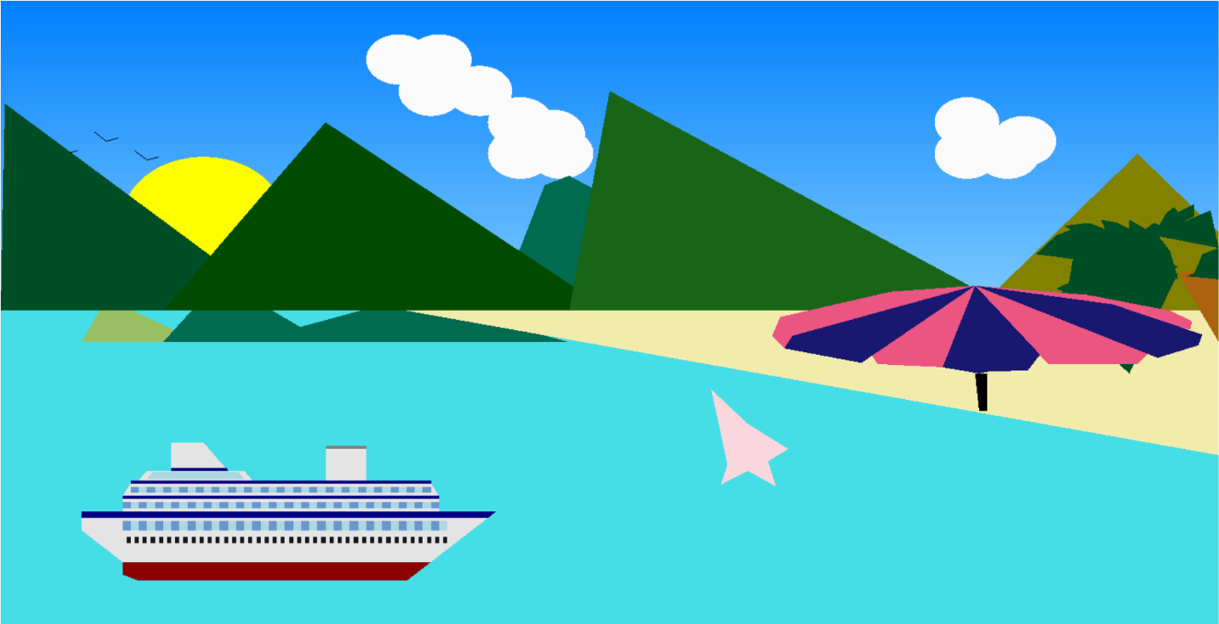

Scene 4:night view
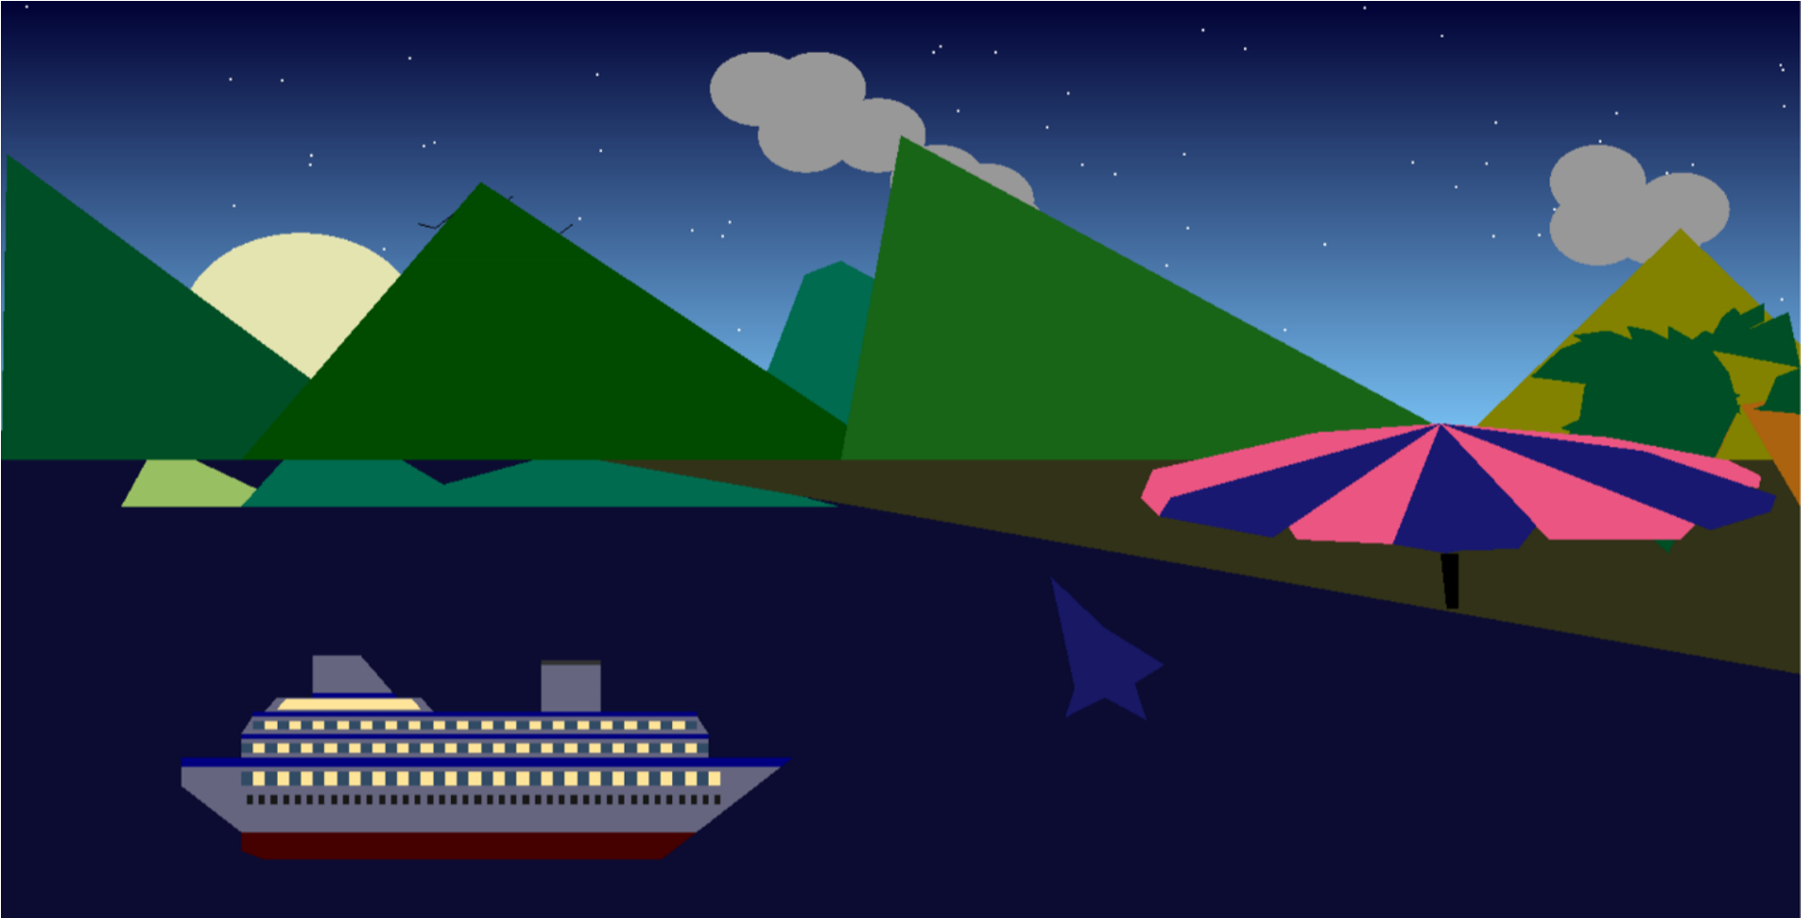

5. Code Availability
The source code of the project is available on GitHub.
GitHub Repository Link:
https://github.com/KishalayDey/-Maritime-World-Journey-computer-graphic-project
The repository contains:
- Complete source code
- OpenGL project files
- Documentation
- Screenshots
- Build instructions

6. Future Work
Several improvements can be added in future versions of the project.

Planned Future Improvements
- Add 3D graphics support
- Add realistic water wave animation
- Add sound effects
- Improve weather systems
- Add more transportation systems
- Add advanced lighting and shadow systems
- Add texture mapping
- Add camera movement system
- Improve user interface
- Add AI-controlled movement systems
The project can also be converted into a complete simulation or educational graphics application.

7. Conclusion
Maritime World Journey successfully demonstrates important computer graphics concepts using OpenGL and GLUT. The project combines transportation systems, environmental simulation, weather effects, and animation into one interactive application.
The project helped the developers understand:
- OpenGL rendering
- Animation systems
- Timer functions
- Event handling
- Object transformations
- Graphics programming concepts

Limitations of the Project
Although the project is functional, there are several limitations:
- Only 2D graphics are used
- Water effects are not fully realistic
- Limited object textures
- No advanced physics system
- Limited user interaction features
Despite these limitations, the project successfully achieves its educational and graphical objectives.

Final Summary
In conclusion, Maritime World Journey is an interactive OpenGL-based graphics project that presents multiple animated scenarios including ships, trains, windmills, weather systems, and beach environments. The project demonstrates creativity, programming skills, and practical implementation of computer graphics concepts. It provides a strong foundation for developing more advanced graphical simulations and multimedia applications in the future.

